WISE TECH INDIA PITCHATHON 2026
ANDHRA EDITION | STARTUP OUTCOME REPORT
27 February 2026 | Vignan Technology Business Incubator (Vignan TBI), VFSTR, Guntur
ORGANISED BY SPJIMR WISE TECH IN COLLABORATION WITH VIGNAN TBI
1. Event Overview
The WISE Tech India Pitchathon 2026 – Andhra Edition was held on 27 February 2026 at Vignan Technology Business Incubator (Vignan TBI), Vignan’s Foundation for Science, Technology & Research (VFSTR), Guntur. Organised by SPJIMR WISE Tech in collaboration with Vignan TBI, the event created a platform for early-stage startups from Andhra Pradesh to present their ventures, demonstrate their solutions, and engage with an experienced jury. The Andhra edition formed part of the WISE Tech India Pitchathon 2026 series.
2. Participation and Pitch Evaluation
Ten startups from across Andhra Pradesh participated, representing a range of sectors and innovative business ideas. The teams presented their solutions, target problems, business potential, and plans for growth before the jury and audience. The jury comprised Siddharth S. Jain and Sandeep Satheesan, who engaged with the founders during the pitch evaluation.
A Business Model Canvas learning session helped founders organise key elements of their ventures, including value propositions, customer segments, revenue streams, and go-to-market approaches. The session complemented the pitching process by connecting innovation with customer needs and business planning.
3. Award-Winning Startups
Award | Startup | Startup Profile
1st Prize | VETDIAG GENOMIX Private Limited | Veterinary diagnostics and animal health. The company focuses on diagnostic services such as molecular testing and PCR-based testing, alongside veterinary laboratory areas including hematology, clinical biochemistry, microbiology, and pathology.
2nd Prize | Anjio MedTech LLP | A healthcare technology venture recognised for its pitch at the Andhra edition. The team presented its startup to the jury and received Second Prize in the competition.
3rd Prize | Grassip | An environmentally conscious product venture developing drinking straws made from natural hollow grass stems. The product is positioned as an alternative to conventional single-use drinking straws.
4. Event Outcomes and Ecosystem Impact
- The pitchathon recognised three outstanding startups: VETDIAG GENOMIX Private Limited secured First Prize, Anjio MedTech LLP secured Second Prize, and Grassip secured Third Prize.
- Provided participating founders with a platform to showcase their ventures to an expert jury and a startup ecosystem audience.
- Strengthened founders’ understanding of business-model design through a Business Model Canvas session covering value propositions, customer segments, revenue streams, and routes to market.
- Enabled founders to receive expert perspectives on communicating their problem statements, presenting their solutions, and explaining their venture potential.
- Reinforced collaboration between SPJIMR WISE Tech and Vignan TBI to encourage innovation and support the development of early-stage ventures in Andhra Pradesh.
- The supplied event photographs document the award presentations, group interaction, and an expert-led learning session.
5. Photographic Documentation
The photographs below capture the award presentation, event participation, pitchathon creatives, and knowledge-sharing activities.
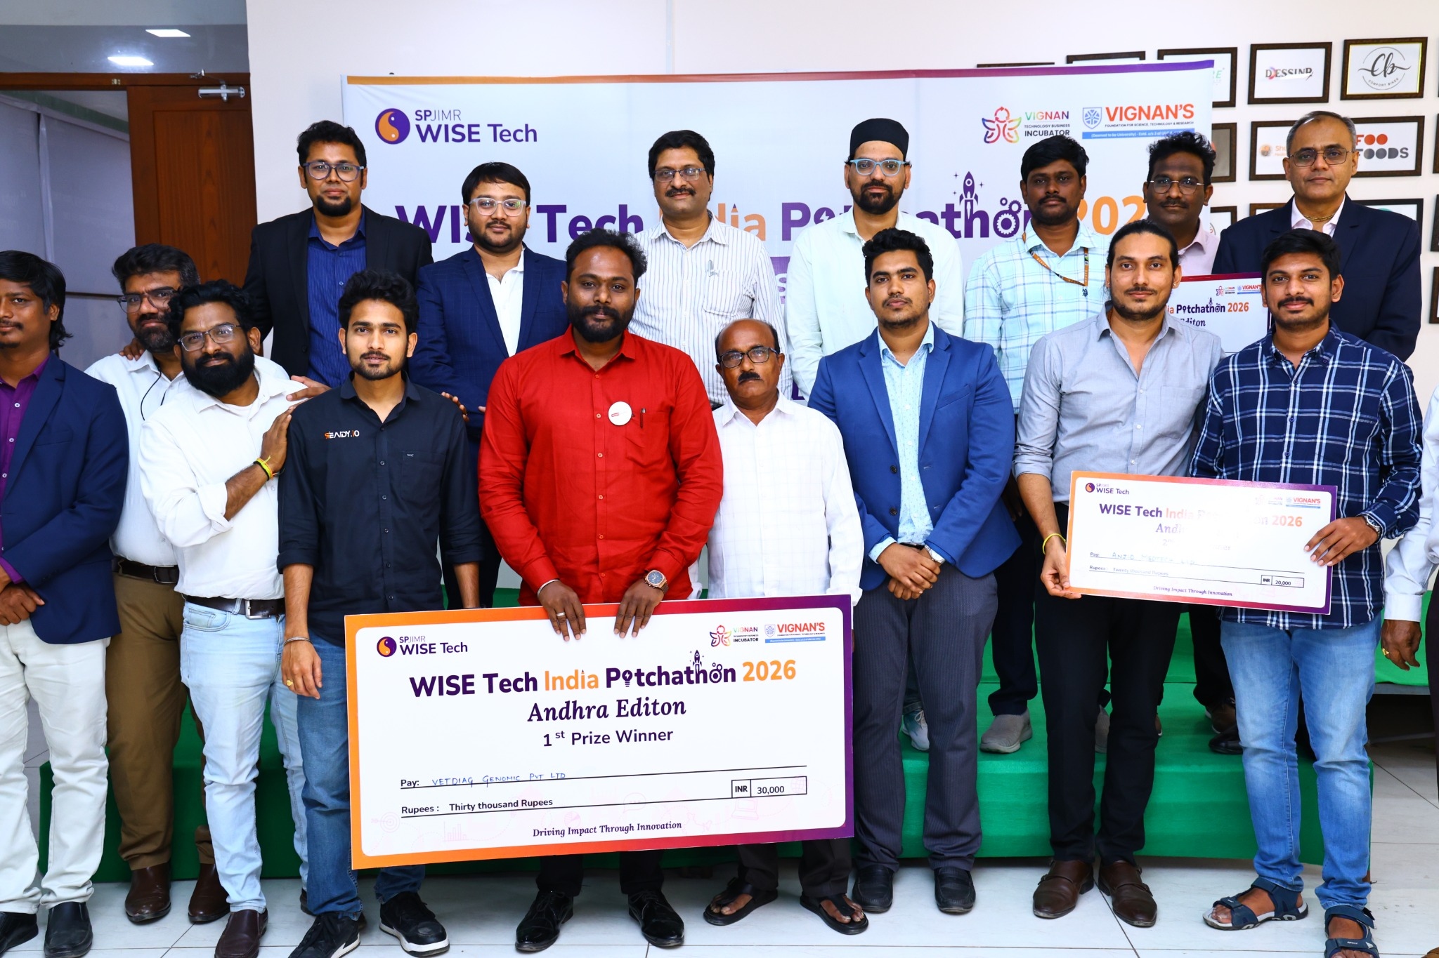  Award presentation to the 1st-prize startup, VETDIAG GENOMIX Private Limited | 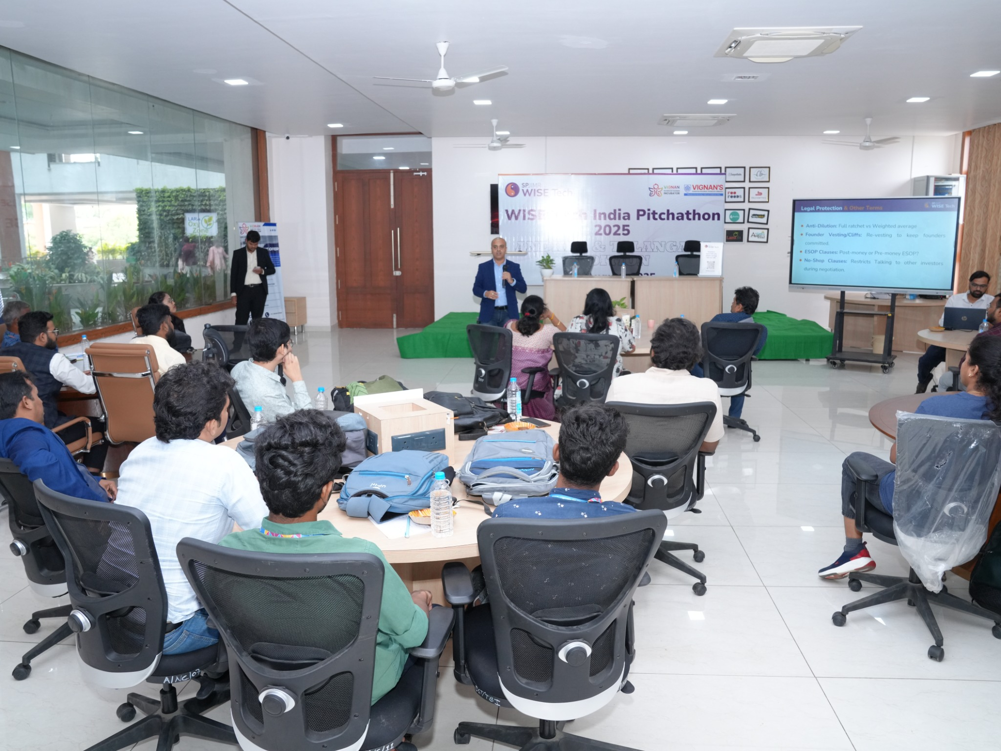  Knowledge-sharing session with participating founders
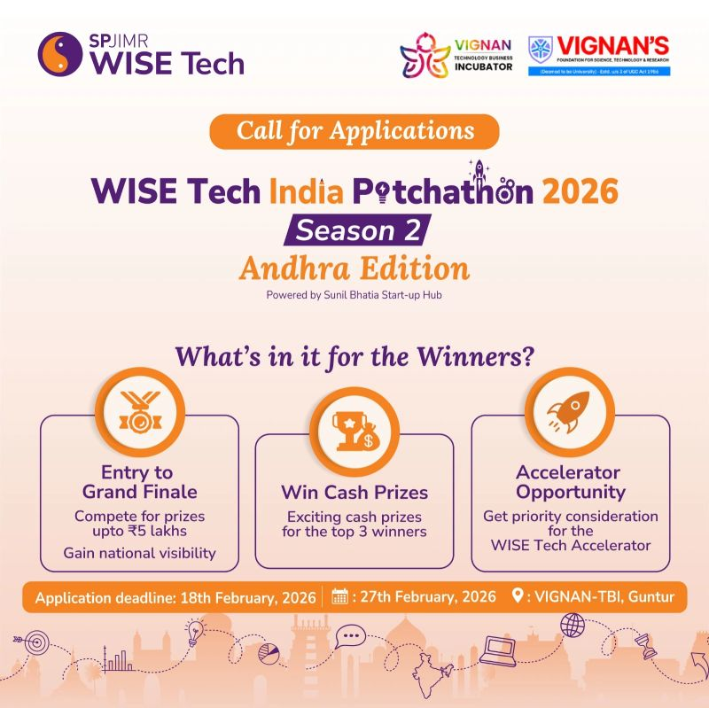  WISE Tech India Pitchathon 2026 – Andhra Edition event creative | 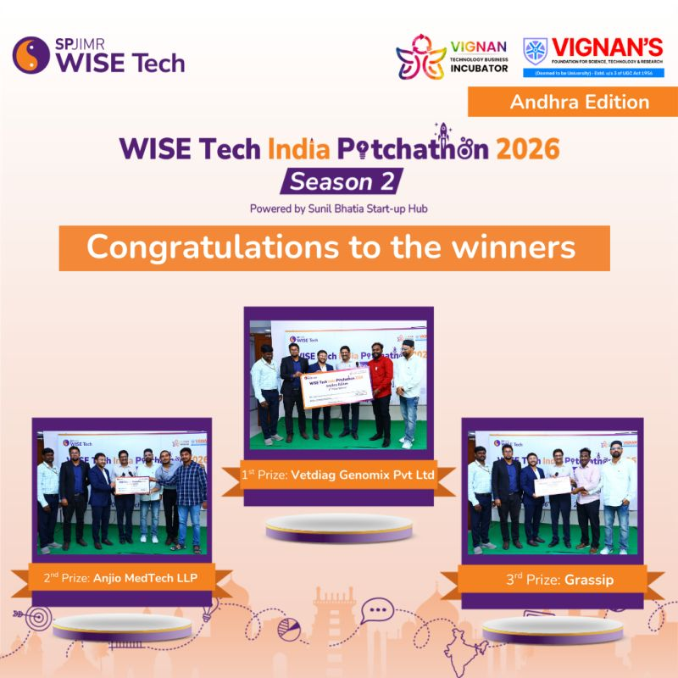  Announcement of the three winning startups
6. Conclusion
The WISE Tech India Pitchathon 2026 – Andhra Edition provided a structured platform for early-stage startups to present their ventures, learn from expert feedback, and gain recognition for their work. The three award-winning startups reflected the range of entrepreneurship represented at the event, from veterinary diagnostics to medical technology and environmentally conscious products. The collaboration between SPJIMR WISE Tech and Vignan TBI contributed to strengthening the regional startup ecosystem and encouraging founders to develop scalable, impact-oriented businesses.

